ACSL
American Computer Science League
2013 - 2014

Contest #3

Classroom Division Solutions Page 1

- Graph Theory

As shown
1.
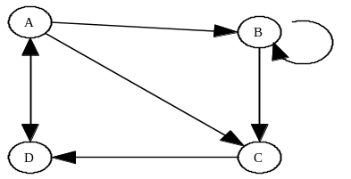

Adding the second row results in 11 paths

- Graph Theory

0 | 1 | 1 | 0 | 1
1 | 0 | 1 | 0 | 0
1 | 0 | 1 | 1 | 0
0 | 0 | 0 | 0 | 1
1 | 1 | 0 | 0 | 0

2. As shown

3. Boolean Algebra
3. (1, 0)

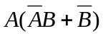 = 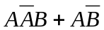 = 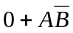 = 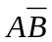
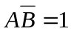 → 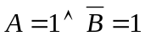 → 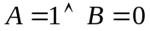 → (1, 0)

4. Boolean Algebra  = 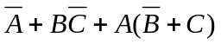

 |  |  | 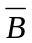 | 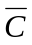 |  | 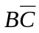 | 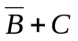 | 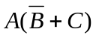
0 | 0 | 0 | 1 | 1 | 1 | 0 | 1 | 0 | 1
0 | 0 | 1 | 1 | 0 | 1 | 0 | 1 | 0 | 1
0 | 1 | 0 | 0 | 1 | 1 | 1 | 0 | 0 | 1
0 | 1 | 1 | 0 | 0 | 1 | 0 | 1 | 0 | 1
1 | 0 | 0 | 1 | 1 | 0 | 0 | 1 | 1 | 1
1 | 0 | 1 | 1 | 0 | 0 | 0 | 1 | 1 | 1
1 | 1 | 0 | 0 | 1 | 0 | 1 | 0 | 0 | 1
1 | 1 | 1 | 0 | 0 | 0 | 0 | 1 | 1 | 1

- 8

- What Does This Program Do?
This program changes entries in the table that are divisible by 4, 3, 10 and 2. Then it counts the entries with a value of 1. The final table is:

5. 6

7 | 1 | 1 | 3
2 | 11 | 1 | 9
7 | 5 | 3 | 1
2 | 1 | 27 | 1

